Math 5 Benchmark 2 Study Guide

Name: | _________________________________________

1. | Shaquille bought 16 bottles of soda. Each bottle has 1.84 quarts of soda in it. How many quarts of juice did Shaquille buy?

2. | Miguel needs to divide 162.80 liters of juice into glass pitchers. If each pitcher will hold 4.4 liters of juice, how many glass pitchers will be needed?

3. | Kimberly’s bag of marbles weighs 2.12 pounds. Jeremy’s bag of marbles weighs 2.4 times as much as Kimberly’s bag of marbles. How much does Jeremy’s bag of marbles weigh?

4. | Mr. Hugans has 9.2 feet of rope. He has to cut pieces of rope that are 1.5 feet long. How many pieces of rope can he cut?

5. | If you increased the number 5.183 by 2 places, what would the number be?

6. | What happens to the decimal point when you multiply 32.78 x 10 ²?

7. | What happens to the decimal point when you solve the problem 89.6 ÷ 10²?

8. | Pasqual solved the problem 925.3 ÷ 10² = 9.253. What do you notice about what happened to the place value?

9. | Julio painted ⅔ of the wall and Patricia painted ⅛ of the wall. How much of the wall was painted?

10. | Zelda completed 3⅓ of the puzzles in the competition. Manuel completed 5½ puzzles in the competition. How many puzzles did Zelda and Manuel complete?

11. | Melissa read 7⅜ books during the summer. Joe read 3¼ books during the summer. How many more books did Melissa read than Joe?
12. Shante earned ¼ of her paycheck on Friday and ⅔ of her paycheck on Monday. How much more of her paycheck did she earn on Monday?

13. | How would you solve ⅓ + ¾?

14. | How would you solve ⅞ - ¼ ?

15. | Linda wrote 5/11 of her paper on Saturday. She wrote 1/3 of her paper Sunday night. How much of her paper has she written?

17. | Susan needs to fill 3 equal-size cups with punch. She pours all of the punch from the 2-quart container into the cups. How much punch is in each of the cups? How would you write this problem using fractions?

18. | What are three ways to write 32 divided by 5?
19. | Mandy baked 39 cookies for 12 friends. How many cookies can each friend have?

20. | The bakery made 238 doughnuts. If a 2 ¼ dozen doughnuts were put in each box. How many boxes of doughnuts were there?

21. | ⅔ of the classes in Brown Elementary School went to the theater. If there were 20 classes in Brown Elementary School, how many classes went to the theater?

22. Write a number sentence which is shown by the model below.

23. | Which problem could be solved using the area model below?  ¼  ⅔

24. | Which choice below is true for the problem ¾ x 4 ?
A. | ¾ x 4 = 3 | B. | ¾ x 4 > 4
C. | ¾ x 4 < 4 | D. | ¾ x 4 = 4

25. | What is true about the product of 9/5 x 5?
A. | The product is equal to 9.
B. | The product is 0.
C. | The product is less than 9.
D. | The product is greater than 9.

26. | Write at least 4 equivalent fractions for ¼.

27. | Is 6/4 x 3 = 4⅔ a reasonable answer? Why or why not?

28. | Nancy’s book had 73 pages. She read ⅝ of the book. How many pages did Nancy read?

29. | The track at the school is ⅜ mile. If George ran the track 9 times, how many miles did he run?

30. | Mrs. Pinder needed fabric to cover the chairs in her house. The fabric she wanted was sold in 1¼ yard segments. She needed 32 segments. How many yards of fabric did she buy?

31. | The prize box contained toy dolls and model airplanes. ⅜ of the toys are dolls . ⅓ of the dolls has brown hair. What fraction of the toys are dolls with brown hair?

32. | John wants to find the area of a rectangular tile measuring 1½ inches by 2⅓ inches.
 | How would you solve this?

 | 33. |  | 8÷ ⅔ =
34. |  | Solve: 3¼ ÷ 1⅔ =

35. | Divide.  28 ÷ 2¼ =
36. | Julia has 4 ⅜ dozen cupcakes. If 1⅔ dozen cupcakes will fit in a box, how many boxes can she fill?

37. | The line plot below shows the number of ounces of soil each student collected for their science experiment. How many students collected ⅝ or less ounces of soil?  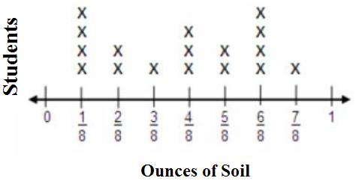

38. | The line plot shows the number of quarts of lemonade in a wooden barrel. How many total quarts of lemonade are in the barrel?  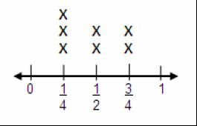

39. | The line plot shows the amount of sugar that will be used to make lemonade. If the sugar was redistributed equally, how many ounces would be in each cup? Reduce your answer to the lowest terms.  Sugar Used for Lemonade (in ounces)  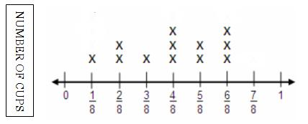

40. | A number of writing club members reported the time they spend writing. The data is shown in the box.  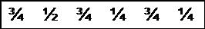  Create a line plot showing this information.

